Question 1

Docker was already installed in the system for previous assignment in second semester

Question 2

Postgress was already installed in the system for previous assignment in second semester

Question 3

Docker build up command

Question 4

Create table

Question 5

Changed code in post05.go to change the port number from 2345 to 5432

Change code to insert the table and delete the second statement same port number changed

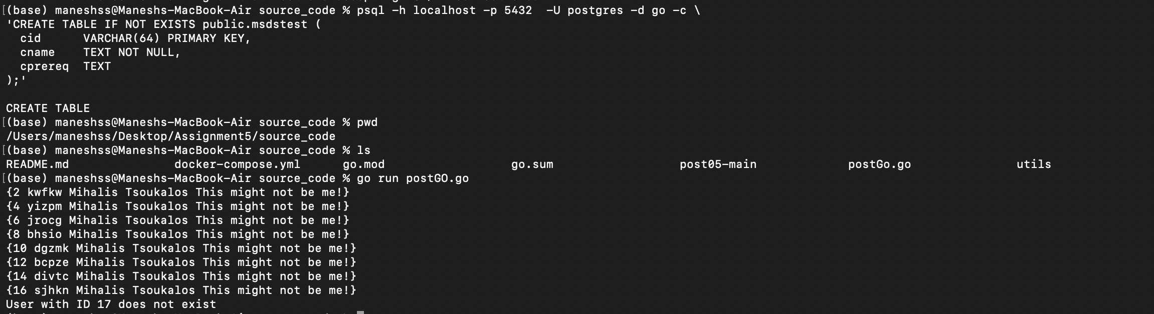

After removal

I truncated the table

psql -h localhost -p 5433 -U postgres -d go -c "TRUNCATE TABLE public.msdstest;"

Point 6



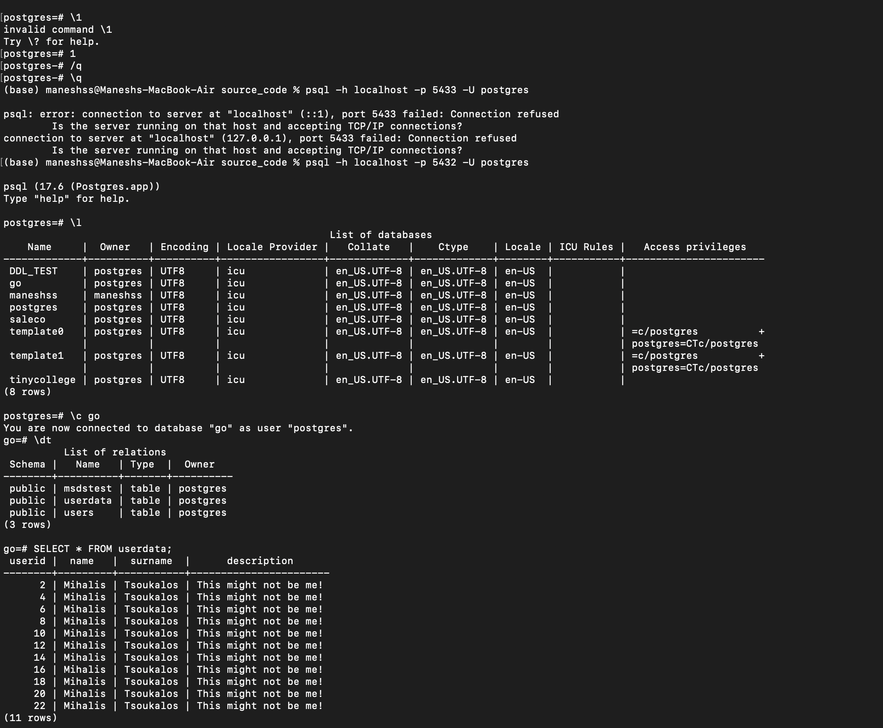

Point 7

Creating database MSDS

Create table

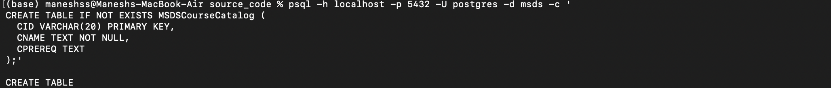

Code for insert inside the table

Question 8

List command

